NAME: ___________________________________ Y3: _________
__________________________________________________________________

ENGLISH

YEAR 3

TERM 2

CONTENTS
Informal Tasks (TERM 2)

Act | Skill | Informal Task | PAGE | MARKS | LEARNER
1 | Listening &  Speaking | Listen to and discuss a poem | 3
2 | Reading Comp | Read the poem and complete questions | 4-6 | 20
3 | Language  Structures | Read the poem and complete questions | 7-9 | 20
4 | Writing &  Presenting | Dialogue | 10-20 | 20
5 | Listening &  Speaking | Listens to and discusses current issues | 13-15 | 25
6 | Reading &  Viewing |  | 16-17
7 | Reading &  Viewing | Reads Newspaper Articles | 18-19 | 15
8 | Reading &  Viewing | Reading Comprehension | 20-21 | 20
9 | Language  Structures | Pronouns, subject & predicate, punctuation, Capital & small letters, Alliteration | 22-26 | 15
10 | Writing &  Presenting | Writes a newspaper article | 2730 | 25

DATE: ____________________________ TOPIC (1): CLIMATE CHANGE
___________________________________________________________________
ACTIVITY 1 LISTENING AND SPEAKING
.......................................................................................................................................
Listen to the poem read by your teacher. Discuss the poem.
A poem on climate change

1. I don’t want my children to see the Earth die,

2. Without fish swim and without birds fly,
3. With no air for breathing, no water to drink,
4. When global conditions will make the land sink.

5. I don’t want emissions to stay in the air,
6. To fill our lungs and to spread everywhere,
7. To cause global warming, submerging the land!

8. To stop all this mess we should lend our hand!

9. The nature is dying together with us,
10. We wouldn’t exist here but for the green grass …

11. We must prevent nature from saying “farewell”-
12. In case it is dying, we’re dying as well!

13. What could human beings’ activities mean-
14. To make our planet one big rubbish bin?!
15. No matter that you may be only a teen –
16. It’s never too early or late to be green!

17. To show our children the beauty of life;
18. To help polar bears and pandas survive;
19. To claim to the world that this talk should gain weight
20. Let’s first take part in the global debate!
(by Julia Melnikova)

DATE: ____________________________ TOPIC: CLIMATE CHANGE
___________________________________________________________________
ACTIVITY 2 READING COMPREHENSION
.......................................................................................................................................
Read the poem and complete the questions
1. Use the words in the box and label the poem.
rhyme line stanza (3)

2. How many stanzas are there in this poem?
(1)

3. Identify the type of figurative language used in the sentence below, and then tick the word that describes it.
“I don’t want my children to see the Earth die” is an example of (1)
oxymoron |  | personification |  | hyperbole |  | metaphor

4. The poem starts with this line: “I don’t want my children to see the Earth die”. The poet then goes on to describe how the earth is being killed off. List four ways she says the earth is dying.
(4)

5. The poet starts the poem by saying what she doesn’t want for her children. In the last stanza she says what she does want for them: “To show our children the beauty of life”. What does she suggest we must do so we can achieve this?
(1)

6. The poem’s title announces that the poem will be about climate change. But the poet also talks about pollution. Write down two types of pollution she speaks about.
(2)

7. Why does she do this? Do you think pollution and climate change are related? Explain why you think so.
(2)
8. Name two animals mentioned in the poem?
(1)
9. Write down the rhyming words in stanza 4.
(3)
10. Identify the figure of speech found in line 10 and tick the correct answer.
We wouldn’t exist here but for the green grass … (1)
assonance |  | metaphor |  | alliteration |  | simile

11. What is the message of this poem?
(1)

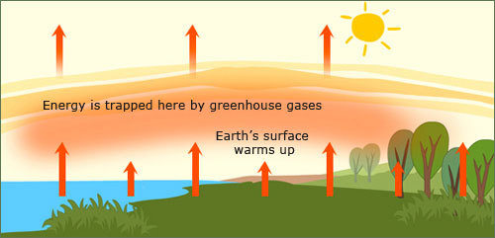

Copy the picture

DATE: ____________________________ TOPIC: CLIMATE CHANGE
___________________________________________________________________
ACTIVITY 3 LANGUAGE STRUCTURES AND CONVENTIONS
.......................................................................................................................................
Read the poem and complete the language questions
1. Identify the common nouns in the extract and write them down.
I don’t want my children to see the Earth die,
Without fish swim and without birds fly …

(4)
2. Choose the correct part of speech for the underlined word in the sentence.
I would not like my children to see the earth die rapidly to the point of destruction.
a) adjective b) noun c) verb d) adverb e) preposition f) pronoun
(1)
3. Fill in the missing verbs (doing words) in the following extract.
With no air for __________________, no water to ___________,
When global conditions will make the land ______________.
(3)

4. Replace the following adjective (describing word) in the sentence with a suitable synonym from the list.
It might become so bad that (large) ______________________ areas of land will be covered by water as the polar ice caps melt.

small
green
huge
polluted
damaged
(1)
5. Match each word in column A with its meaning in column B. Write the correct word in the Answer column.
A | Answer column | B
global |  | discharge
emissions |  | flood
mess |  | worldwide
submerge |  | disorder
(4)
6. Change the two simple sentences to a compound sentence. Use the conjunction “because”
The earth is dying. We are destroying it.
______________________________________________________________________________________________________________________________________
(4)

7. Write the following sentence in the negative.
We are turning the earth into one big rubbish dump.
______________________________________________________________________________________________________________________________________
(2)
8. Write down the opposite word for ever.
______________________________________
(1)

TOTAL: (20)

DATE: ____________________________ TOPIC: CLIMATE CHANGE
___________________________________________________________________
ACTIVITY 4 WRITING AND PRESENTING
.......................................................................................................................................
1. Read the discussion between Sue and Dave about how to stop the climate from changing by taking care of the environment.
2. Use the discussion between Sue and Dave to write a dialogue. Pay attention to the correct format.
3. Use the information in the box to help you.
INFORMATION BOX
1. Dialogues are written in the direct speech.
2. There are no inverted commas. “................” x
3. Write the speakers name on the left hand side followed by a colon (:)
4. Write the dialogue on the right hand side.
5. Leave a line open between each speaker.

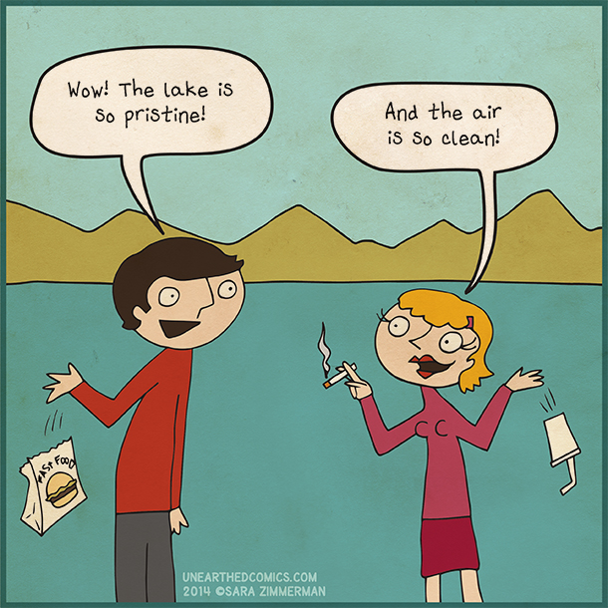

A discussion about climate change: Cartoon strip.
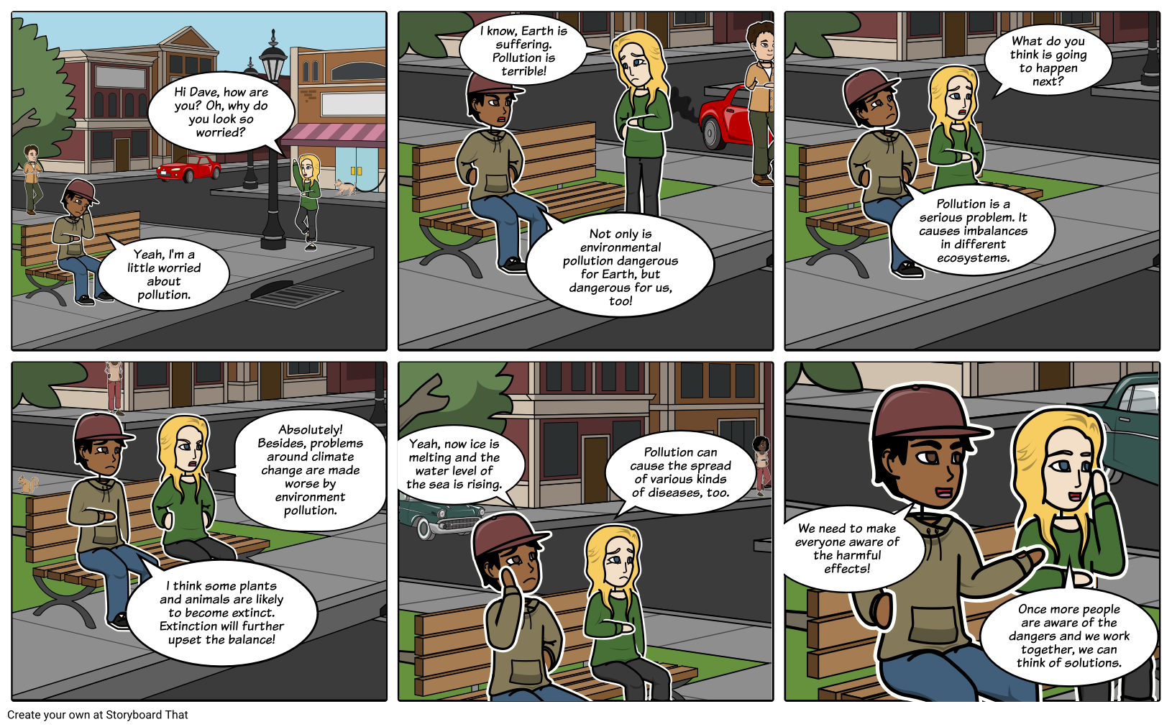

Write the following extract from the discussion in dialogue form.
Sue says, “Hi Dave, how are you? Oh, why do you look so worried?”
Dave replies, “Yeah, I’m a little worried about pollution.”
Sue approaches Dave and answers, “I know. Earth is suffering. Pollution is terrible!”
“Not only is environmental pollution dangerous for Earth, but dangerous for us, too!” exclaims Dave.
Sue joins Dave on the bench and asks, “What do you think is going to happen next?”
Dave responds, “Pollution is a serious problem. It causes imbalances in different ecosystems.”

Write your Dialogue here:

TOTAL: (20)

DATE: ____________________________ TOPIC (2): IN THE NEWS
___________________________________________________________________
ACTIVITY 5 LISTENING AND SPEAKING
.......................................................................................................................................
Listens to and discusses current issues
What to do
1. Look at the pictures and headings and try to predict what the text will be about.
2. Listen to your teacher reading the newspaper reports.
3. Discuss the safety issues in each of the reports.

T oddler rescued from river

A three year old girl has been pulled from a river by a schoolboy, Dumisani Mkize from the East Coast Primary school in KwaZulu-Natal. Two days ago, the toddler was left in the care of her eight-year-old sister. Her sister became distracted by friends. The toddler wandered off to the river. Mrs Smith of the Department of Social Development says that children must always be supervised by a responsible adult.
Dumisani Mkize

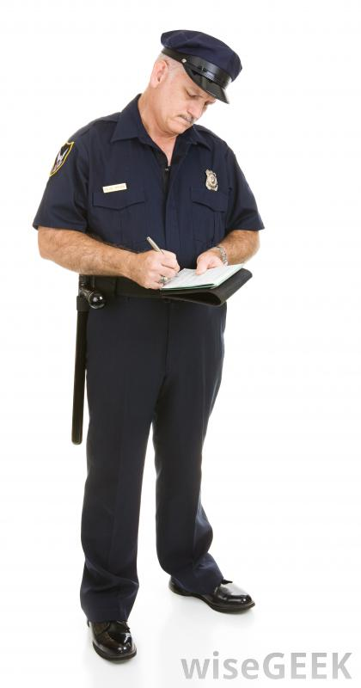
POLICE RESCUE KIDNAPPED SCHOOLGIRL
Yesterday the SAPS rescued a schoolgirl who had been missing for three days. The police believe she was kidnapped by child traffickers, who were hoping to sell the child across the border. Police arrested three men in Mpumalanga in connection with the kidnapping. Officer Muller of the SAPS warns that children should never go anywhere with strangers.
Officer Muller


Children in overloaded bus injured
A driver of the Deepside Taxi bus company in Gauteng was charged in the Deepside Magistrate’s Court today with overloading a mini bus taxi. He had packed 29 children into a 10-seater bus, which then overturned. Many children were injured.
Mr. Sekgobela of the Department of Transport says school children must report overloading, drunken drivers or vehicles that are not roadworthy to their school principals.

Burning mattress sets house on fire
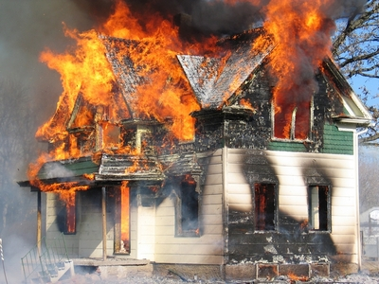
Three children were evacuated from a burning house in the Free State last night. The fire was caused when one of the children knocked a candle over onto the mattress they were sleeping on.
Officer Skosana of the Riverside Fire Department warns children not to handle candles, paraffin stoves, or any flammable substances.

ASSESSMENT: Listening and speaking
Criteria / Skills | Marks | Achievement
Participation in discussion | 10
Ability to express self orally | 10
Understanding of text (listening) | 5
TOTAL | 25

Comment
_______________________________________________________________________________________________________________________________________________________________________________________________________________________________________________________________________________________________________________________________________________

Rubric: listening and speaking
Listening and speaking
25 marks
Marks | 9–10 | 6–8 | 3–5 | 1–2
Participation in group discussion  * Respond with respect | Takes an active part in the discussion; listens to others with respect; takes turns | Takes part in the discussion; listens to others with respect; takes turns | Takes part in the discussion adequately; able to listen and follow; few interruptions of others | Takes very little part in the discussion; does not listen to others; or frequently interrupts others; does not follow the thread of the conversation
Marks | 9–10 | 6–8 | 3–5 | 1–2
Ability to express self orally  * Retell events in correct order  * Express thoughts & feelings  * Ask relevant questions | Expresses her/himself very well. Able to say what he/she wants to say clearly and easily with few or no mistakes. | Expresses him/herself well. Able to say what he/she wants to say clearly and fairly easily, but with some mistakes. | Expresses him/herself with some difficulty. Struggles to say what he/she wants to say and makes many mistakes. | Struggles to express him/herself orally. Makes many mistakes. Difficult to understand. Says only one or two words.
Marks | 4–5 | 3–4 | 2–3 | 1–2
Understanding of text (listening)  * Predict  * Identify plot, characters & setting  * Main message | Discusses and answers all or most questions skilfully; shows excellent understanding of the text | Discusses and answers most questions correctly; shows good understanding of the text | Discusses and answers some simple questions correctly; shows adequate to moderate understanding of the text | Discusses and answers most elementary questions incorrectly; shows little or no understanding of the text

DATE: _____________________________ TOPIC: IN THE NEWS ___________________________________________________________________
ACTIVITY 6 READING COMPREHENSION
.......................................................................................................................................
Look at each of the articles on pages 13 and 14 again. Then fill in the answers to the questions in the table.
 | What is the headline? | What was the problem? | On what date did the event happen?


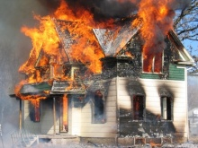

Look at each of the articles on pages 13 and 14 again. Then fill in the answers to the questions in the table.

 | In what province did it take place? | What is the message?

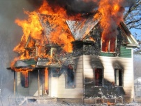

DATE: _____________________________ TOPIC: IN THE NEWS ___________________________________________________________________
ACTIVITY 7 READING AND VIEWING
.......................................................................................................................................
Read the newspaper article out loud.

NEWS TODAY 31 March 2016

School eats its way to success

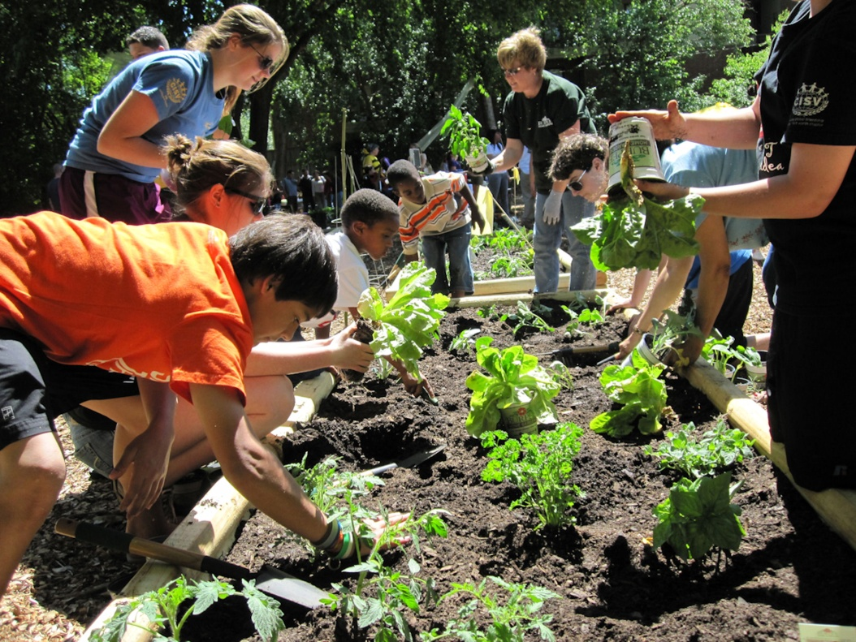
New Town School provides vegetables for families in the New Town village.

1. The Grade 9 teacher, Mr. Joseph started a school gardening project in September last year. Every Friday, the New Town children take vegetables home for their families. Presently the school supplies vegetables for 50 families.
2. In addition, the school uses vegetables from the school garden for school lunches for 500 children. Vegetables supply the vitamins that people need to protect them from illness.
3. Dr Baloyi, spokesperson for the Department of Health, says: “vegetables are very healthy.” Dr Baloyi also says that the “secret weapon” of the school’s soccer team is the healthy food provided by the school. The players are stronger and healthier than they were last year.
4. Mr. Joseph says the project will expand. “I hope that more children will join the gardening club. We all need to work hard for a healthy community.”

Rubric for reading aloud
CRITERIA | MARKS | ACHIEVED
reads with appropriate pronunciation (says words correctly; easy to understand) | 3
reads fluently (does not stop on every word; easy to understand ) | 3
reads with appropriate expression (varies and uses voice to express the meaning of words and sentences; speeds up and slows down appropriately) | 3
understands what is read (answers a few questions correctly about what he/she has read) | 3
shows understanding of direct speech (reads words and sentences in direct speech in a natural way) | 3
TOTAL | 15

DATE: _____________________________ TOPIC: IN THE NEWS ___________________________________________________________________
ACTIVITY 8 READING AND VIEWING
.......................................................................................................................................
Read the newspaper article on page 18 again and answer the questions.

1. What is the name of the newspaper? (1)
___________________________________________________________________
2. What is the main headline? (1)
___________________________________________________________________
___________________________________________________________________
3. Why does this headline attract our attention? Tick the appropriate answer. (1)
3.1 This headline attracts our attention because it is boring. ______
3.2 This headline attracts our attention because it’s about food. ______
3.3 This headline attracts our attention because it’s catchy and funny. ______
3.4 This headline attracts our attention because it’s about school. ______

4. In which month did Mr. Joseph start a school gardening project? (1)
___________________________________________________________________
5. What do they use the vegetables for? (2)
___________________________________________________________________
___________________________________________________________________
6. Why are vegetables healthy foods? (2)
___________________________________________________________________
___________________________________________________________________

7. Circle the correct answer in brackets.
7.1 Dr Baloyi is a spokes person for the Department of (Education / Health). (1)
7.2 The New Town children take vegetables home for their families (1)
once a (month / week).
8. What is the soccer team’s secret weapon of success? (1)
___________________________________________________________________
9. Do you think the gardening project is a good thing or a waste of time? (2) Give a reason for your answer.
___________________________________________________________________
___________________________________________________________________
___________________________________________________________________
10. What in your opinion is Mr. Joseph’s attitude towards healthy living? Why do you say so? (2)
___________________________________________________________________
___________________________________________________________________
___________________________________________________________________
11. Give another word that means the same as the underlined word in (1) the sentence.
Vegetables supply __________________ the vitamins that people need to protect them from illness.
12. Write down names of two vegetables that you like the most. (2)
______________________________________________________________
13. Do you think Mr. Joseph cares about people? Explain your answer. (2)
______________________________________________________________
______________________________________________________________
______________________________________________________________

Total (20) _____
DATE: _____________________________ TOPIC: IN THE NEWS ___________________________________________________________________
ACTIVITY 9 LANGUAGE STRUCTURES
.......................................................................................................................................
Read the newspaper article on page 18 again and answer the language questions.
1. Write the underlined words in the correct columns. (6)
Mr. Joseph started a school gardening project in September last year. Every Friday the children take vegetables home for their families.
Proper nouns | Common nouns

2. Fill in the missing pronouns. (7)
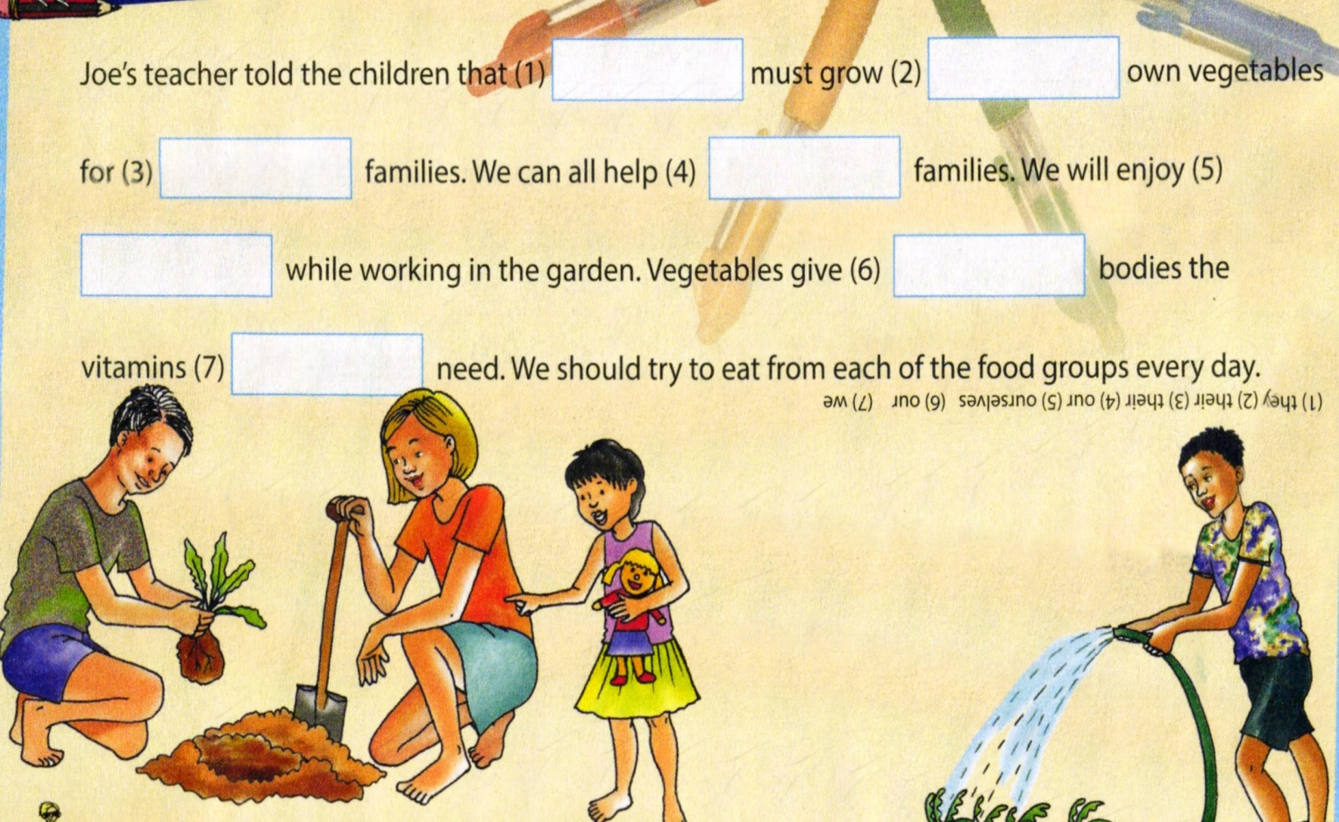

3. Rewrite these sentences using the correct punctuation and spelling.
3.1 this is thatos book (4)

3.2 the teacher asked where is your homework (6)

3.3 on Wednesday peter and bongani will go to polokwane (6)

4. Use the bolded words in each table to join the sentences. Connect the first part of each sentence in column A to the correct part in column B to make a complete sentence. We call the complete sentence a complex sentence.
A B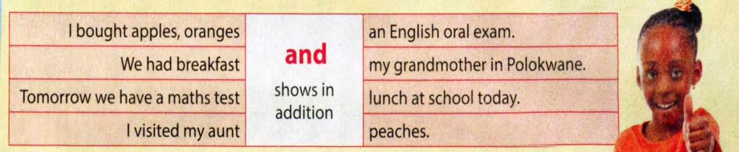
and
4.1 (1)
___________________________________________________________________
___________________________________________________________________4.2 (1)
___________________________________________________________________
___________________________________________________________________
4.3 (1)
___________________________________________________________________
___________________________________________________________________

4.4 (1)
___________________________________________________________________
___________________________________________________________________
A B
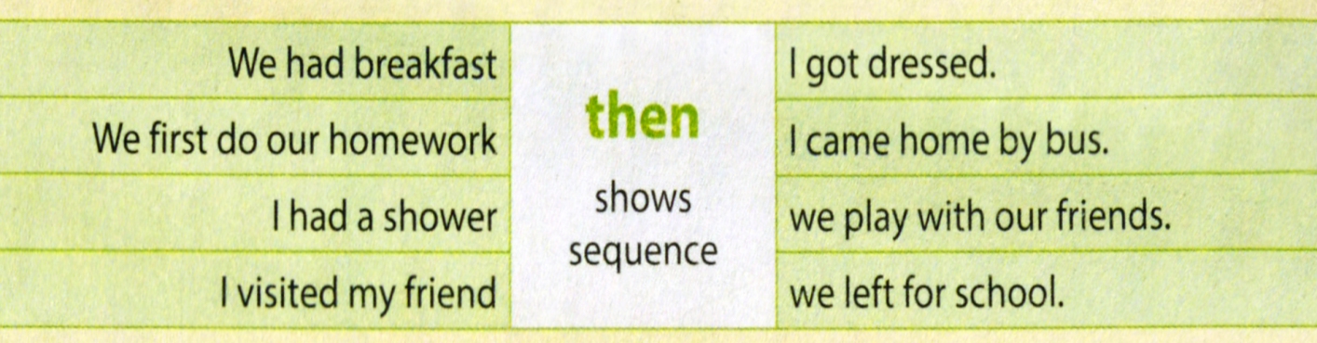
then
4.5 (1)
___________________________________________________________________
___________________________________________________________________4.6 (1)
___________________________________________________________________
___________________________________________________________________
4.7 (1)
___________________________________________________________________
___________________________________________________________________
4.8 (1)
___________________________________________________________________
___________________________________________________________________

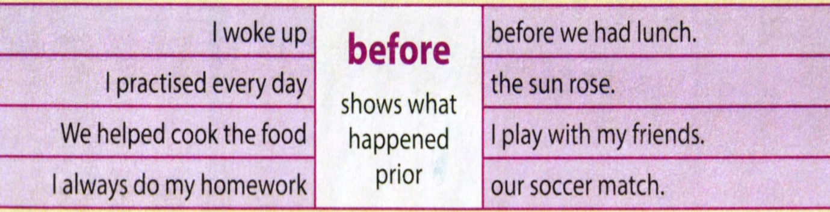
before

4.9 (1)
___________________________________________________________________
___________________________________________________________________4.10 (1)
___________________________________________________________________
___________________________________________________________________
4.11 (1)
___________________________________________________________________
___________________________________________________________________
4.12 (1)
___________________________________________________________________
___________________________________________________________________

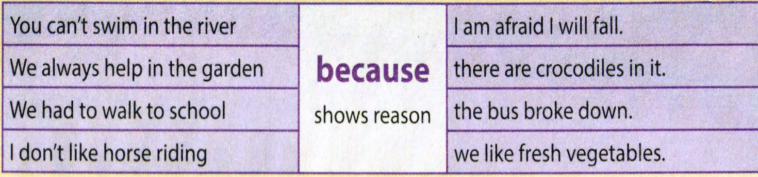
because

4.13 (1)
___________________________________________________________________
___________________________________________________________________4.14 (1)
___________________________________________________________________
___________________________________________________________________
4.15 (1)
___________________________________________________________________
___________________________________________________________________

4.16 (1)
___________________________________________________________________
___________________________________________________________________

Total: (45÷3=15) ______

DATE: _____________________________ TOPIC: IN THE NEWS ___________________________________________________________________
ACTIVITY 10 WRITING AND PRESENTING
.......................................................................................................................................
Write a newspaper article
RULES for writing a good newspaper article
1. First paragraph
In your first one or two sentences say who, what, when, where and why. Try to attract the reader’s attention by beginning with a funny, clever or surprising statement.
2. Second / third paragraphs
Give the reader the details. Include one or two quotes from people you interviewed. Use inverted commas to show what the experts say.
3. Last paragraph
End with a quote or a catchy phrase.
What to do
Follow the writing process and write a newspaper article. Choose one of the following headlines. Schoolboy knocked over by car. / Toddler drinks paraffin.
First, create a mind map. Next, write your first draft. Then, edit your work. After that you must write your final presentation. Good luck!

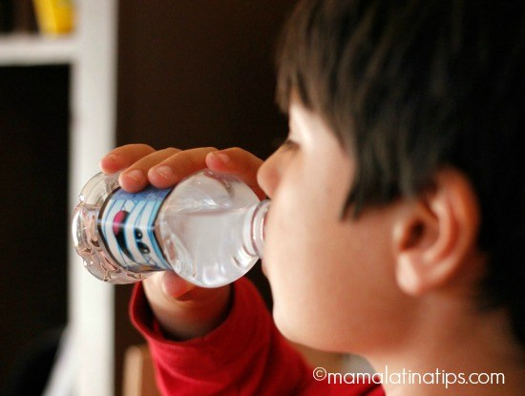
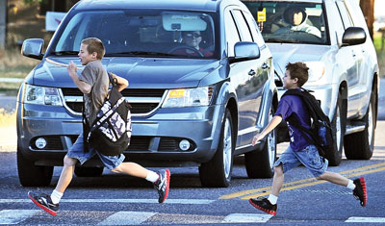
SCHOOLBOY KNOCKED OVER BY CAR
TODDLER DRINKS PARAFFIN

Planning your newspaper article
2

1

HEADLINE

3

4

Rough Draft
Headline
__________________________________________________________________
____________________________________________________________________________________________________________________________________________________________________________________________________________________________________________________________________________________________________________________________________________________________________________________________________________________________________________________________________________________________________________________________________________________________________________________________________________________________________________________________________________________________________________________________________________________________________________________________________________________________________

Final Presentation
_______________________________________________________________________________________________________________________________________________________________________________________________________________________________________________________________________________________________________________________________________________________________________________________________________________________________________________________________________________________________________________________________________________________________________________________________________________________________________________________________________________________________________________________________________________________________________________________________________________________________________________________________________________________________________

Rubric for the marking of a newspaper article
25 marks | Level 4 | Level 3 | Level 2 | Level 1
 | 16 - 20 | 12 - 15 | 6 – 11 | 0-5
Content: Writes suitable content for the topic | Very interesting and creative content, suitable for the topic, correct text type  Who, what, when, where and why. attract the reader’s attention by beginning with a funny, clever or surprising statement. | Mostly relevant interesting content, some mistakes with text type and not all on the topic | Some material on the topic and suitable, many mistakes in text type | Mostly not about the topic, or not the right length (has written only one or two sentences); or not the correct text type
 | 5 - 4 | 3 | 2 | 1
Language and vocabulary use | Uses language well; uses interesting vocabulary | Uses language and vocabulary fairly well | Little control of language and vocabulary | No control over language or vocabulary

Criteria | Marks | Achieved
Content | 20
Language / Vocabulary | 5
TOTAL | 25

COMMENT
_________________________________________________________________________________________________________________________________________________________________________________________________________

